RJ De Guzman

public void addGroup(String name, String desc) {
1 int id = groupSeq.getAndIncrement();
2 TransactionGroup g = new TransactionGroup(
id, name,
3,4 desc == null || desc.isBlank() ? null : desc, null);
5 transactionGroups.put(id, g);
activeProfile.getTransactionGroups().add(g);
transOperations.setTransactionGroup(g);
transOperations.createTransactionGroupDB(g);
}

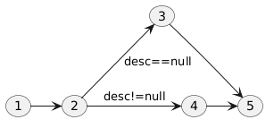
Cyclomatic complexity: 5-5+2*1 = 2
Paths:
- 1 → 2 → 3 → 5
- 1 → 2 → 4 → 5

